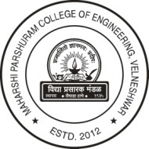 | Vidya Prasarak Mandal’s  Maharshi Parshuram College of Engineering, Velneshwar  At: Velneshwar, Hedvi-Guhagar road, Taluka: Guhagar,  Dist: Ratnagiri (Maharashtra) 415 729  (AICTE & DTE approved and affiliated to University of Mumbai) | Tel No. 02359-243102/3/4  Fax No. 02359-243102  E-mail: mpcoe@vpmmpcoe.org  URL:www.vpmmpcoe.org

3.1 Resource Mobilization for Research

Vidya Prasarak Mandal has strong research promotion culture and policy for students, teachers and staff members. The policy promotes participation in all research activities, higher studies and internship program. Policy also comprises provision of resources and guidance facilities for the promotion of research. Institute also encourages students and teachers for their postgraduate and doctoral studies.

